Week 10 - Root Finding & Optimization

_________________________________________________________________

**Objectives:**

→ Learn how to identify and solve problems using root-finding techniques.

→ Learn how to identify and solve problems involving optimization. This week, you’ll learn how to find minimum and maximums for 1-dimensional and 2-dimensional functions.

**Onboarding material:**

1. **Video onboarding to roots :** [**link here**](https://video.vt.edu/media/BSE%203144:%20Onboarding%20to%20Roots/1_yuwhmyny)

Roots of equations are used in engineering in problems where you have an equation where you’re not able to rearrange the equation and solve directly.

1. **Video onboarding to optimization** [**here**](https://video.vt.edu/media/t/1_7d8873uf)**.**

This video will walk you through background and approach.

1. **Basic description (single unknown, can’t solve directly, single root for variable)**

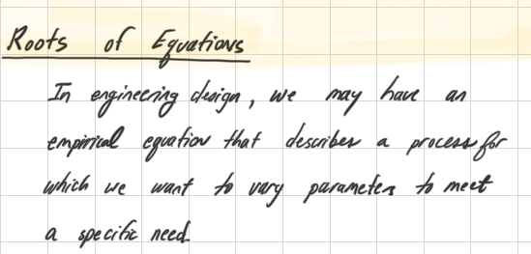

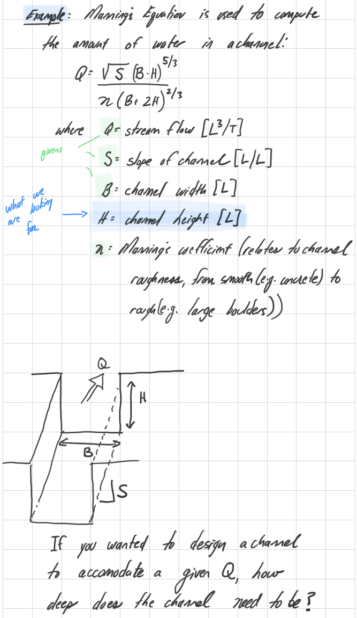

**Assumption:**

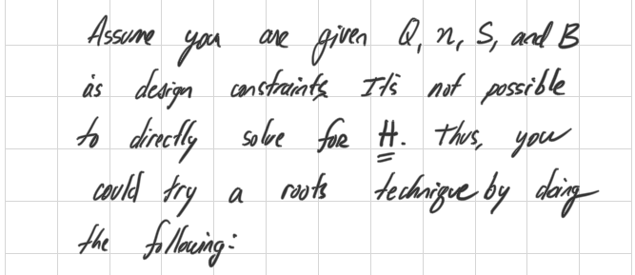

**Approach:**

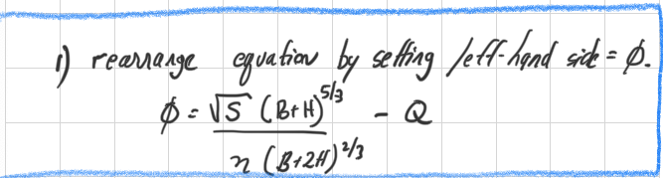

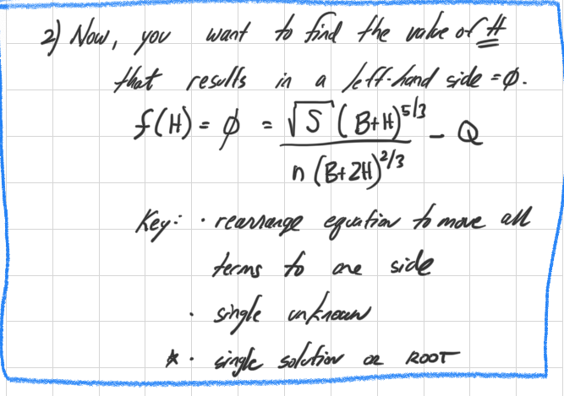

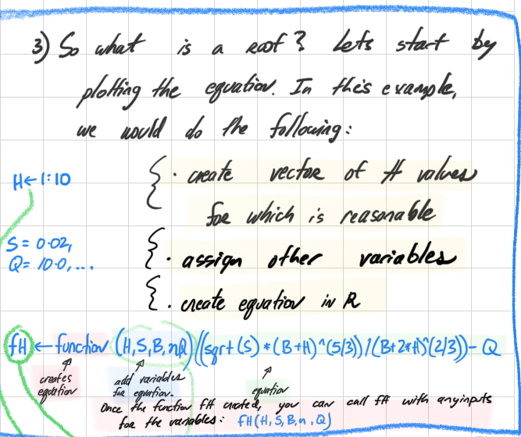

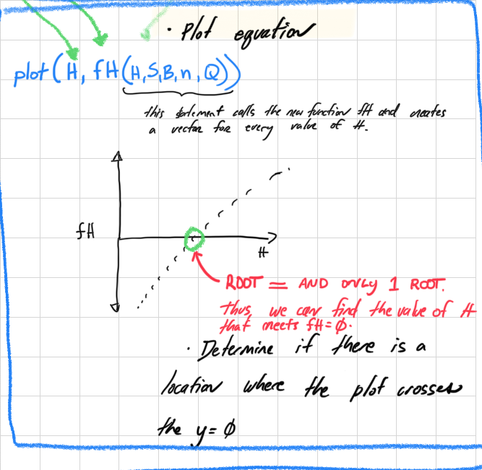

**Summary:**

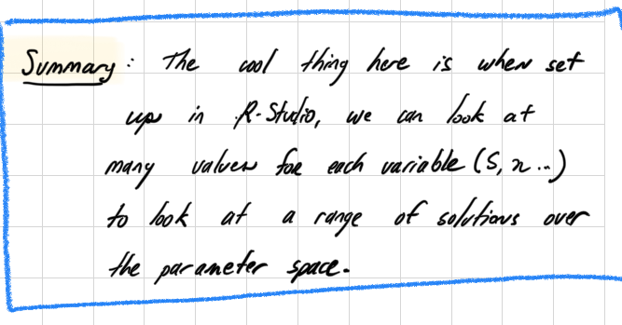

**Overview of Optimization**

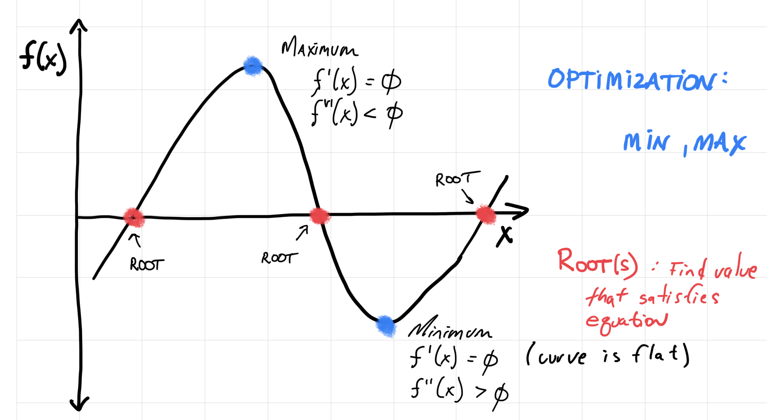

**Key functions (to include in your cheat sheet):**

optimize

function

data.frame

ggplot

plotly

meshgrid

**Exercises:**

On Monday, we will answer questions related to the pre-class exercises in Posit/R-Studio (Week 10 in Rstudio).

**Homework:**

This week, we have [a couple of problems including a cheatsheet](https://drive.google.com/file/d/1ROFWNk1v8eWIiYcBx74u7s6-n9QfTVxZ/view?usp=sharing) for root finding.

Additionally, [we have a couple of problems](https://drive.google.com/file/d/12YsARvX7e3booCA8xU4rcyCfoYn7PubL/view?usp=sharing) focusing on optimization (also included with your cheatsheet) in the beginning. The intention is that you will largely be able to complete in class on Wednesday.